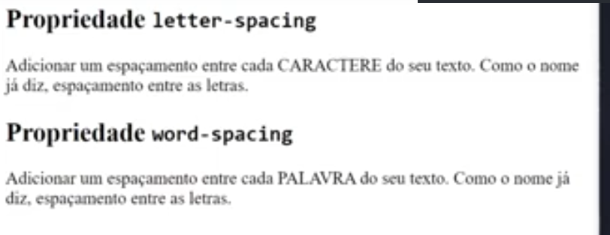

# Latter Spacing

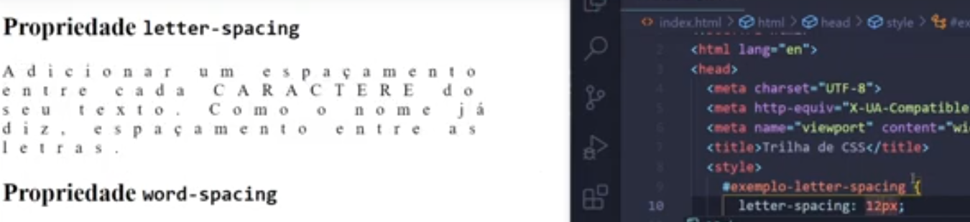

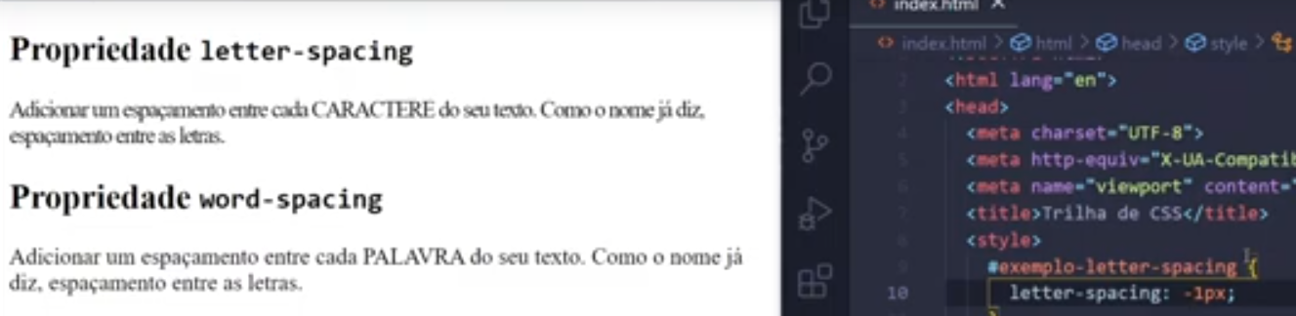

# Word Spacing

